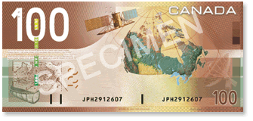
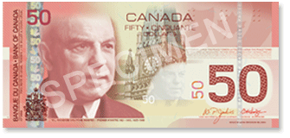
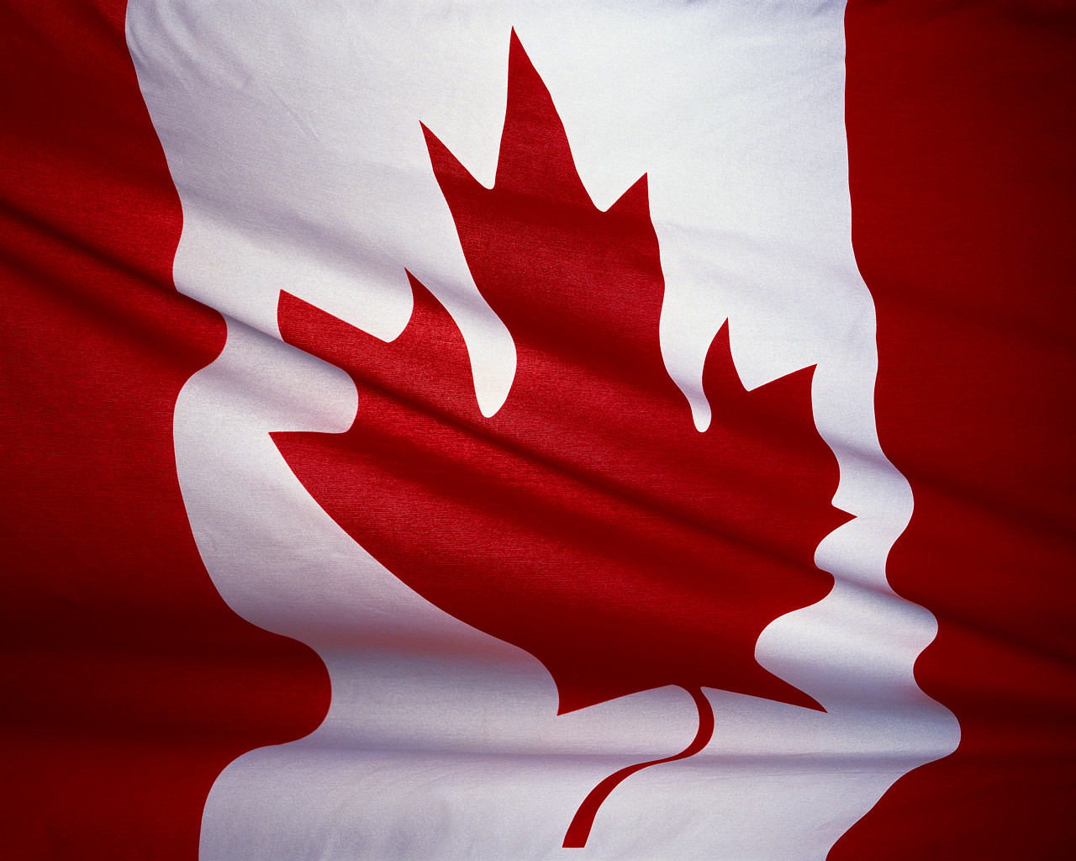
The Great Canadian Three Dollar Bill Assignment
(Canadian Identity)

Task:
The Bank of Canada has recently decided that a three-dollar bill is long over-due and has requested that YOU design one for them. The Bank of Canada is giving you almost complete artistic freedom in this project but does have a few requirements. They are as follows:

Requirements:
- The bill must be two-sided and state the denomination ($3)
- The bill must have original images on both sides that symbolize Canada’s heritage and pride.
  - One of the symbols must be an historical figure who stands as an exemplar as to what it means to “be Canadian”.
- The bill must be as original and interesting as possible (i.e. not a copy of other bills and coins)
- The bill must have some form of security feature on it (the Government does not want it to be easily counterfeited)

Explanation:
The Bank of Canada would also like a write up explaining how the symbols and images you used on the bill represent Canada. Due to the symbolic nature of currency you must also explain your choice of colours (or lack thereof). Your explanation must be written in a professional paragraph(s) (It is the Government after all).

The due date for this assignment is__________________.
You will have two classes to work on this project. Good Luck!
(Hand in this sheet with your $3 design)

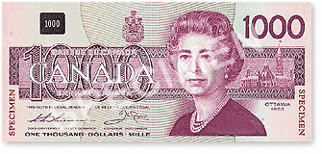
Evaluation:
See Reverse
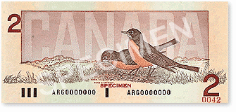

Three Dollar Design Name:_________________
Rubric

Overall Appearance
5 | 4 | 3 | 2 | 1
It is obvious that a great deal of time and care have been given to creating a bill with a smart look. Layout is effective and the viewer feels drawn in. Visual components are well balanced. | Your bill looks quite good. There may be parts where work is needed on neatness or layout, but overall this is a visually appealing product. Visual components are well balanced. | You bill looks fairly good but more attention could have been given to neatness and layout. Your visual components may be imbalanced. | Your bill needs work: Layout and or neatness are problem areas. Your visuals are imbalanced, unclear and/or confusing. | Your bill needs work. Layout and/or neatness are definite problem areas. There seems to be too much happening, or not enough with your visuals. Much more effort is needed.

Content
10 | 8 | 6 | 4 | 1
The symbols you have selected are original and all clearly connected to the theme of Canadian identity. Your written explanation demonstrations a strong relationship between the symbols and Canadian Identity. | The symbols you have selected are largely original and all clearly connected to the theme of Canadian identity. Your written explanation demonstrates a clear relationship between the symbols and Canadian Identity | The symbols you have selected are largely standard and are generally connected to the theme of Canadian identity. Your written explanation demonstrates a general relationship between the symbols and Canadian identity. | The symbols you have selected are standard and generally connected to the theme of Canadian identity. Your written explanation is unfocused in making a clear connection between the symbols and Canadian identity. | The symbols you have selected are not connected to the theme of Canadian identity. Your written explanation is unfocused and no attempt is made to connect the symbols to Canadian identity,

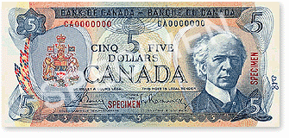
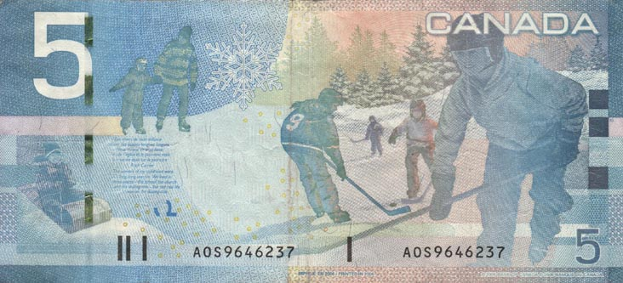
Comments:

