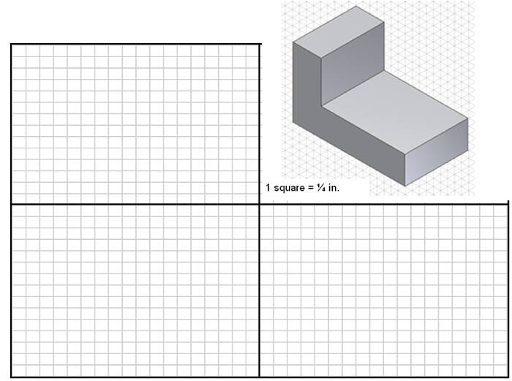
Assignment Name:___________________________________________________

TASK: Draw 3rd Angel Orthographic Drawings and add necessary dimensions to the drawing.

