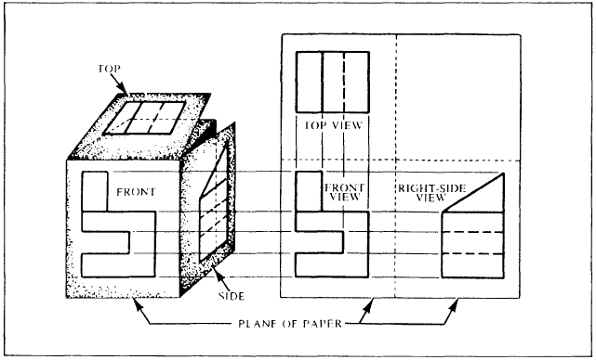

**Drafting and Design 9/10 Name:__________________________________**

**Orthographic Projection**

Task #1: Interpret this 3rd Angle projection and do a freehand 3d drawing of what you think the object looks like in the top right space.