Module 1: Government and Law

Section 2: The Citizen and Government

Electoral Process Practice Quiz--KEY
Name: ________________________ Block: ______
1. A party platform is

A. pre-determined destinations to be visited on the campaign trail.
B. the proposals put forth by a political party during an election campaign.
C. the list of candidates representing a political party during an election campaign.
D. a record of legislation passed by a political party.

2. For a bill to become a law in Canada, which of the following does NOT have to occur?

A. It must receive Royal Assent.
B. It must be passed by both the Senate and the House of Commons.
C. It must be read three times.
D. It must be passed by the British House of Lords.

Use the data below to answer questions 3 and 4.

The Canadian House of Commons has 308 seats. Consider the following hypothetical Canadian election results. The numbers below represent seats in the House of Commons held by each party.

Liberal Conservative New Democratic Party Bloc Quebecois Other
144 117 21 23 3

3. Based on the given data, we would have

A. a minority government.
B. a majority government.
C. an immediate new election.
D. none of the above.

4. Based on the given data, the official opposition would be the

A. Liberal Party.
B. Conservative Party.
C. Bloc Quebecois.
D. New Democratic Party.

5. In order to be elected in a riding, a candidate must win more votes than

A. two thirds of the other candidates.
B. half of the other candidates.
C. every other candidate.
D. the majority of candidates.

6. It is possible for a government to win a majority government with less than 50% of the popular vote.
A. True B. False

7.
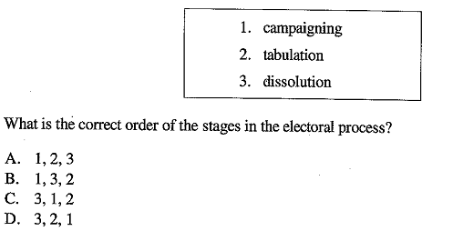
C. 3, 1, 2

8.
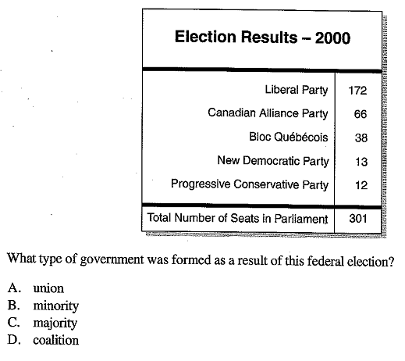
C. Majority
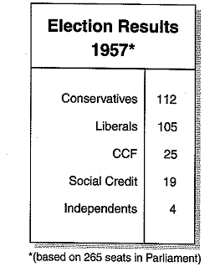
9.
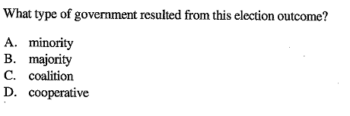A. minority

