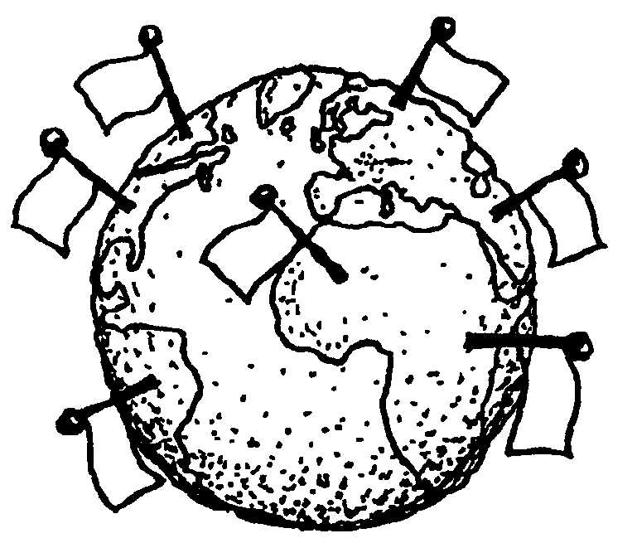

Course Content:

Social Studies 11 continues the study of contemporary Canada, which was introduced in grade 10. The focus at the grade 11 level is government, politics, and 20th Century Canadian history.

In addition, you will examine Canada’s relations with the rest of the world. The transition to a global perspective will be made through an investigation of such major concerns as population growth, the distribution of resources, and the impact of industrialization and technology on modern society.

Geographic knowledge and skills previously acquired are reinforced and expanded. The discussion of current events is considered integral to this course.

Course Modules:

Module 1: Politics and Government
 | Section 1: | The Structure of Canada’s Government
 | Section 2: | The Citizen + Government
 | Section 3: | Canada’s Legal System
 | Module 2: History 1914–1945
 | Section 1: | Canada's Role in World War I
 | Section 2: | The Roaring Twenties
 | Section 3: | The Great Depression
 | Section 4: | Canada's Role in World War II
 | Module 3: History 1945–2000
 | Section 1: | Canada's International Role
 | Section 2: | Canada's Changing Society
 | Section 3: | Canada's Changing Identity
 | Module 4: Human Geography
 | Section 1: | Population
 | Section 2: | Standards of Living and Poverty
 | Section 3: | Environmental Challenges

What Do I Need for This Course? (Resources)
In addition to paper, pen/pencil you will need:
- Binder with dividers
- Counterpoints: Exploring Canadian Issues (textbook)
- Flashcards (5+ packages) or electronic device for Quizlet
- Pencil crayons, glue stick, and ruler

Mount Doug Cell Phone/Electronic Device Policy
Unless given permission by the classroom teacher (digital devices may be used in class by students at the teacher’s discretion), the student code of conduct requires that all students keep their cell phones/electronic devices turned off and stored in a backpack or purse during instructional time.
Students who choose not to abide by this rule can expect the following series of consequences to be enforced:
1. The first time a student uses his/her cell phone/electronic device during class time, the teacher will contact the parents with a reminder of the school’s policy and a request that they discuss with their child the importance of keeping his/her
phone/device off and away.
2. The second time a student uses his/her cell phone/electronic device during class time, the teacher will confiscate the device and the student will collect it from the office at the end of the day.
3. The third time a student uses his/her cell phone/electronic device during class time, the student and his/her parents will be asked to contact an administrator/counselor to work out a solution for the continued misuse.

