Drafting and Design 9/10 Name:___________________________
Drawing Assignment

Bedroom 3D Model

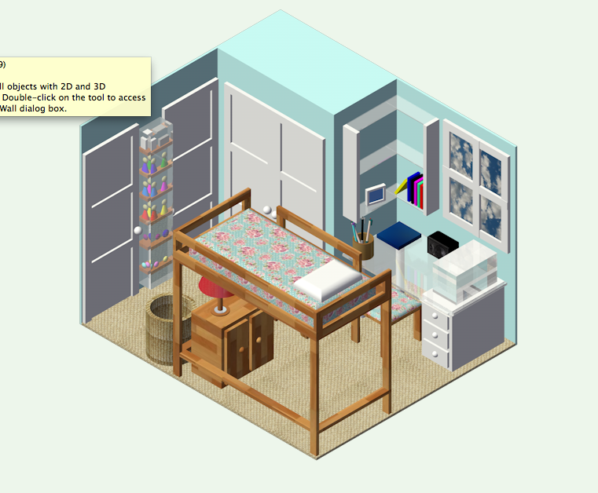
TASK:
Using your 2D bedroom floor plan as a sketch:
- Create a 3D model of your bedroom.
- Use architectural tools (wall, door, window, plug ins tools)
- Texture components of your room.
- Remove one (or two) walls in order to highlight the features of your model
- Hand in colour-rendering with 2D floor plan attached.

PROCEDURE:
- Open 2D bedroom floor plan file. Create “3D Model” layer
- Draw walls in Top/Plan view (trace on top of your 2D plan using show/snap)
- Add doors and windows as necessary.
- Draw furniture models or use plug ins from resource browser. Make as accurate as possible.
- Place your 3d Lamp and Flashlight on a surface of your 3D model (desk or nightstand)
- Texture your bedroom with as much accuracy as possible.

Presentation
Your will need to hand in the following final copies all on title block templates:
- 2D floorplan (with dimensions)
- 3D model in colour from best angle (final quality, 300 DPI)

Evaluation
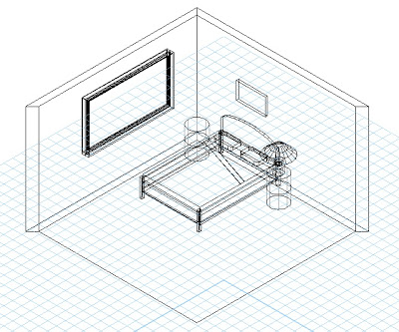
Your 2D and 3D drawings will be marked on:
-Accuracy of scaling and dimensioning.
-Cleanliness of lines in all drawings.
-Effectiveness of texture, light applications.
-Inclusion of lamp and flashlight
-Choice of angles for final rendering and printing.

