Drafting and Design Name:_______________________________
3D Modeling Project

Object:
To further knowledge of 3D design and modeling techniques, students will choose a project from the list below to design and draw.

Requirements:
In order to earn full marks, students will need to demonstrate their application of the design process:
- Evidence of research (photos, dimensioning info, sketches etc.)
- 2D planning layer(s) with orthographic views of design.
- 3D Model Layer(s)
- Video Presentation (iMovie with audio and text)

Project Suggestions:
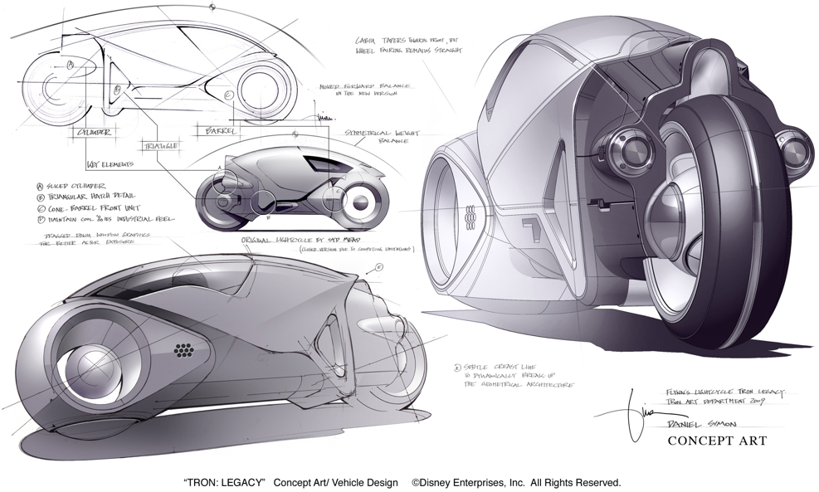
Design suggestions:

Recreational Design
- a board game (eg: chess)
- dartboard
- Sci-fi space/land craft
- Wall clock
- Car wheel
- Sports arena or field of play
Transportation-based
- Bicycle
- Scooter
- Motorcycle
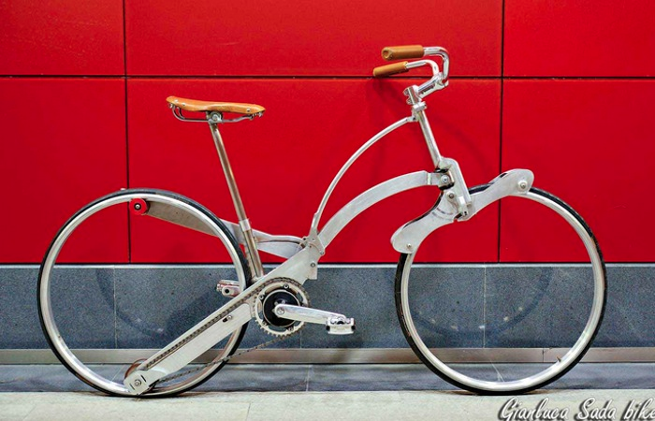
- Light Rail Transit (train)
- 3-wheeled vehicle
- redesigned road to accommodate
multiple transportation-forms
Architecture-based
- Dream room
- Renovation and/or addition plans of a house kitchen
- Cottage in the woods
Mechanical
- a complex machine part
- a power tool with cross section
Geometry study
- celtic knot design
- 2d or 3d logo for personal or corporate use
- dartboard or other game board
- musical instrument
http://www.sadabike.it/en/the-bike-project/
Consumer product
- new appliance or electronic device
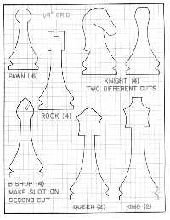
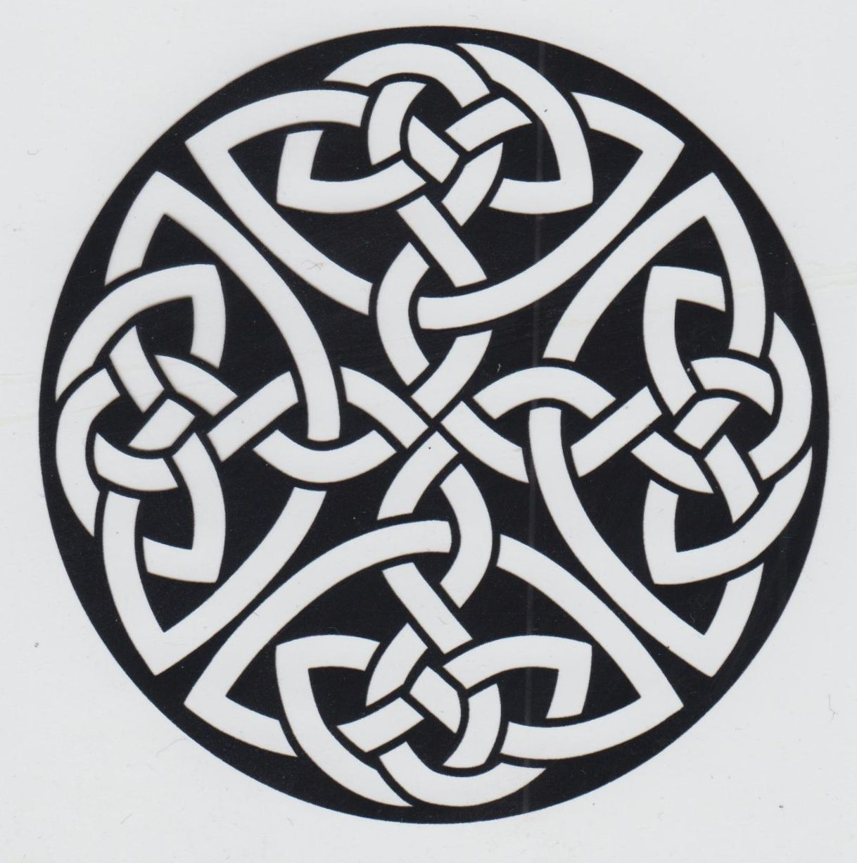
- Power tool
- A toy
Landscape Design
- Back or Front yard renovation
(Including deck and paved structures)
- Public green area
Theatre Design
- Set design(s) from a favorite play/musical
Green Design
- New recycling station for Mount Doug

Evaluation
Your project will be evaluated on the following criteria:
-Research
-Accuracy
-Form and function
-Aesthetics & creativity

