Drafting and Design 9/10
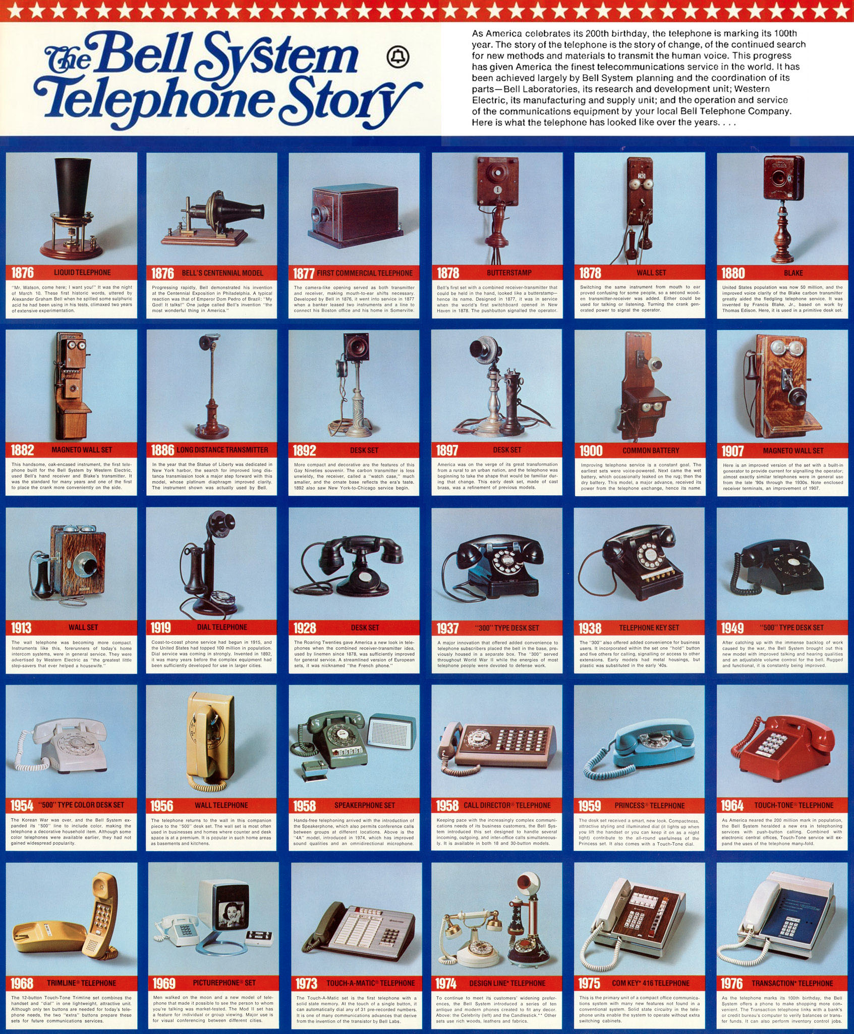
Design Evolution Timeline

•Using powerpoint, chart the progress or evolution of a design of at least 2 products of your choice.
•Use the internet to find 5-6 images product for your slides.
•Identify the approximate production year below each image.
•Choose images that best reflect the significance in change of design.
•On last slide, write a sentence or two that comments on the overall design changes for each product

